Formula SAE,
Mini Baja,
Solar Car,
& Zeus
Prototype Vehicles

PROCEDURES

Updated: September 30, 2014

TABLE OF CONTENTS

1) BUILDING THE PROTOTYPE VEHICLE 3
a) Team Sign-Up Sheet: 3
b) Volunteers at the University of Calgary: 3
c) Waiver: 3
d) Health Insurance: 3
2) INSURING THE PROTOTYPE VEHICLE 4
a) Insurance 4
b) Values 4
c) Prototype Vehicle Identification: 4
3) DRIVING VEHICLES 4
a) Authorization to Drive the Prototypes OR University Owned or Rented Vehicles: 4
b) Waiver for Drivers of the Prototype Vehicle: 6
c) Use of the Prototype Vehicle in Alberta, including On-Campus: 6
4) RENTING AND DRIVING UNIVERSITY-OWNED OR RENTAL VEHICLES 7
a) Rental Vehicles: 8
b) Letter for the Rental Company: 8
c) Use of Donated Vehicles: 9
d) Use of Personal Vehicles: 9
e) Transporting the Prototype Vehicle: 9
f) Use of Trailers: 9
5) ACCIDENTS OR INJURIES 10
6) PARTICIPATING IN CANADIAN EVENTS 10
a) Event Organizer Requirements: 10
b) University of Calgary Requirements: 10
7) PARTICIPATING IN INTERNATIONAL EVENTS 10
a) Shipping the Vehicle: 11
b) Health Insurance for Student Participants: 11
c) Health Insurance for Volunteer Participants: 11
d) Taking the Prototype Vehicle into the United States: 11
e) Travel Registration Form for International Travel: 11
f) Traveling Through the Sweetgrass/Coutts Border Crossing: 12

This document outlines the processes required in order to build, drive or enter an Event with a prototype vehicle. All forms mentioned in this document can be found on-line at https://www.ucalgary.ca/riskmgmt/vehiclesdrivers/solar-mini-baja-and-formula-sae-cars

BUILDING THE PROTOTYPE VEHICLE

Team Sign-Up Sheet:

Complete the Team’s Sign-Up List sheet. Each participant must be a University of Calgary student unless otherwise approved in writing by Risk Management & Insurance (RM&I).

Volunteers at the University of Calgary:

Each participant is considered a Volunteer and will require complying with the details found on RM&I’s website at: http://www.ucalgary.ca/riskmgmt/Volunteers.

The Faculty/Departmental Supervisor is responsible to ensure that the following forms have been completed for each participant:

Volunteer Registration and Release of Liability, Waiver of Claims and Assumption of Risks:

https://www.ucalgary.ca/riskmgmt/system/files/Volunteer_registration_and_waiver_of_liability.doc

WCB Reporting Form for Volunteers (this form can be done for all participants at the end of each semester):
https://www.ucalgary.ca/riskmgmt/system/files/WCB-Volunteer-Reporting-Sheet.xlsx

Waiver:

Each Participant that is building a Vehicle must sign the FSAE, Mini Baja, Solar Car & Zeus – Working On/Building - Adult Waiver. The Waivers must be signed, dated, initialed and witnessed and are to be retained by the Department or Faculty Supervisor for a period of 10 years. They must be produced upon request from RM&I.

Health Insurance:

All participants should review their personal health insurance to determine if they have adequate coverage. The University does not provide any health insurance for any participants while building, driving or supporting the Prototype Vehicle other than for University of Calgary employees.

INSURING THE PROTOTYPE VEHICLE

  - Insurance:

Insuring the Prototype Vehicles is done on an annual basis. The insurance policy period of coverage for all Prototype Vehicles (other than the Solar Car) is January 1 – December 31. The Solar Car coverage is July 1 – June 30.

In October of each year, please contact RM&I by email at riskmgmt@ucalgary.ca provide the value of the Prototype Vehicle and the value of any extra components (i.e. batteries) that are part of the Prototype Vehicle that needs to be insured.

NOTE: This insurance will not cover the Prototype Vehicle for damage while it is being driven but only while it is in storage.

  - Values:

The 2014 values for the Prototype Vehicles are as follows:
- Formula SAE - $70,000
- Mini Baja - $25,000
- Zeus - $15,000
- Solar Car - $100,000

Prototype Vehicle Identification:

- A707 is the vehicle number for the Mini Baja vehicle.
A708 is the vehicle number for the FSAE vehicle.
A709 is the vehicle number for the Zeus vehicle.
071 is the vehicle number for the Solar Car.
- The trailer for the FSAE vehicle is T862 – license # P223-41.
- The trailer for the Solar Car is T819 – license # T62572
- If you are retaining more than 1 Prototype Vehicle in a year, please contact RM&I at riskmgmt@ucalgary.ca to issue a vehicle number for the second Prototype Vehicle.

DRIVING VEHICLES

Authorization to Drive the Prototypes OR University Owned or Rented Vehicles:

Drivers Registration Form – Each driver must:
    - Be a University of Calgary registered student;
    - Complete the Drivers Registration process which includes:
      - Completing the on-line Drivers Registration Form found at: https://iac01.ucalgary.ca/riskmgmt and login as required under the Central Authentication Service (CAS);
      - Under ‘Driving With the University’ select the Faculty Unit: Schulich School of Engineering and the Department: SSE Student Activities.

      - You must complete a Drivers Registration Form to drive the Prototype Vehicle as well as any other University Owned or Rental Vehicles while being a FSAE, Mini Baja or Zeus Team participant. This applies even if you have already been approved to drive a vehicle for another department or group other than the FSAE, Mini Baja or Zeus Teams.

Please ensure that this is done at least 3 weeks in advance of when you are required to drive the Vehicle.

A new Drivers Registration Form will need to be completed again upon the expiry date of your on-line application as indicated by your Faculty/Departmental Supervisor.

      - Once the on-line form is submitted, it will automatically be sent to the Department Approver. Once the Approver indicates his/her approval, you will be sent an email with follow-up information required. Obtain and provide a scanned copy of your Driver’s Abstract and email it to riskmgmt@ucalgary.ca. If RM&I approves your on-line application, you will be added to the Approved Driver’s List and you will be insured any time that you are driving the Prototype Vehicle or a Rental Vehicle that is being driven for this event.

NOTE: Drivers must receive the Approval email from RM&I that indicates they are now approved to drive before they can drive any type of vehicle.

If a department wishes a volunteer to drive on behalf of the FSAE, Mini Baja, Solar or Zeus Vehicles, please email riskmgmt@ucalgary.ca with the name of the driver, the department and the reason for which they are required to drive on your behalf.

Drivers Registration Form – Each Volunteer driver must:
    - Complete the Drivers Registration process which includes:
      - Completing the on-line Drivers Registration Form found at: https://iac01.ucalgary.ca/riskmgmt and login as required under the Central Authentication Service (CAS) as indicated below;
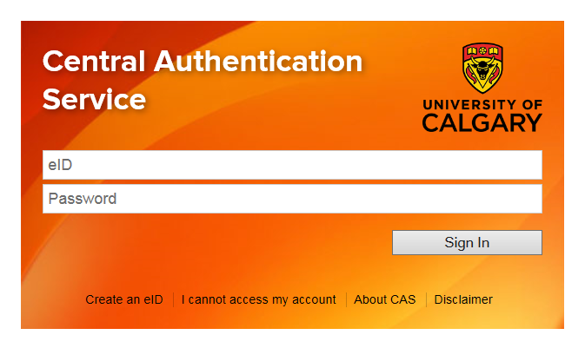
Click on – Create an eID
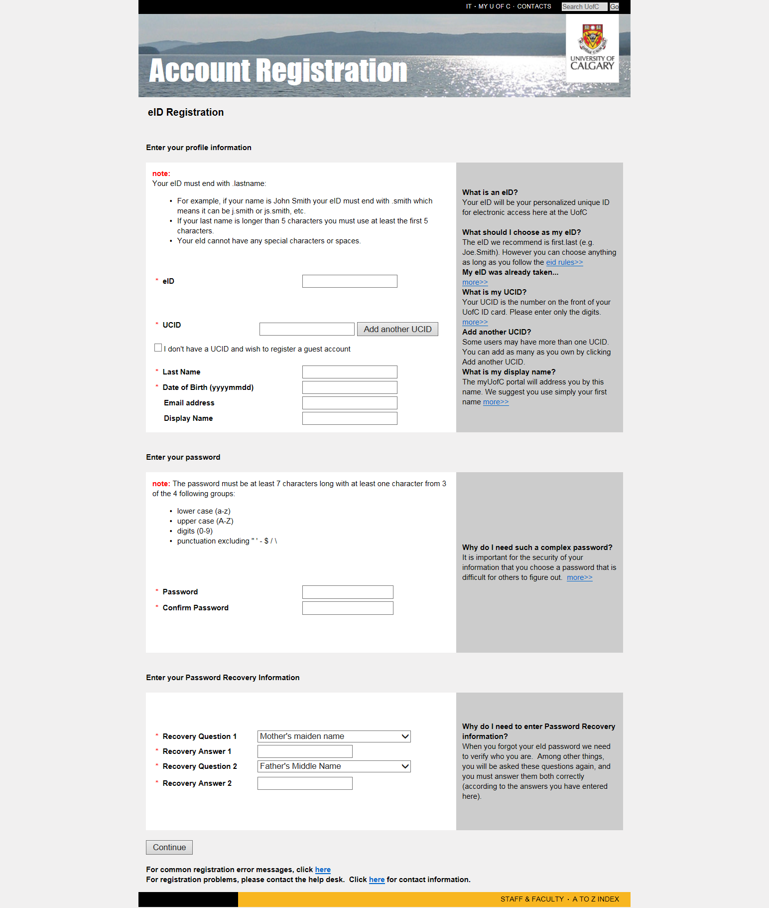
The enter information under ‘I don’t have a UCID and wish to register a guest account’.

      - Under ‘Driving With the University’ select the Faculty Unit: Schulich School of Engineering and the Department: SSE Student Activities.
Please refer to RM&I’s website at: http://www.ucalgary.ca/riskmgmt/volunteerdrivers for the full details of what is required for Volunteer Drivers.
    - NOTE: Drivers for FSAE, Mini Baja and Solar Car Vehicles must have a full Valid Class 5 license as outlined in the Alberta Traffic Safety Act with less than 7 demerits.
    - Drivers for the Zeus Vehicle must have a full Valid Class 6 license as outlined in the Alberta Traffic Safety Act with less than 7 demerits.
    - A Graduated Driver’s License (GDL) is NOT acceptable. An equivalent level is required if the Driver’s License is outside of Alberta/Canada.
    - All drivers must review and comply with all University of Calgary FSAE, Mini Baja, Solar Car or Zeus Safety Regulations (whichever is applicable). A copy of your safety regulations should be sent to RM&I at riskmgmt@ucalgary.ca annually.

Waiver for Drivers of the Prototype Vehicle:

Each individual that will be driving a Prototype Vehicle during the Training, Pre-qualification or during the Event/Competition will be required to sign the FSAE, Mini Baja & Zeus Vehicle Training / Pre-qualification / Events – Adult Waiver. Please obtain this waiver from the RM&I’s website.

Use of the Prototype Vehicle in Alberta, including On-Campus:

- The Faculty/Department Supervisor is responsible to create and keep an on-going log of the removal of the Prototype Vehicle and/or Trailer from the storage area. This includes date, time, signature, location that it is going to, and when it is returned.

- Use of the Prototype Vehicle on Campus: Prior to commencement, permission to use Testing Sites must be obtained in writing (i.e. e-mail) and the Team is responsible to ensure a record will be kept of who gave the permission and the time/date that the permission was given. Any use of the Prototype Vehicle in a parking lot or roadway on campus requires the written permission from the Grounds Manager or if in a Parking Lot, Parking & Traffic Services Manager.

Please ensure that they are provided with your request well ahead of time or set up a schedule with them. The Parking Lot must be barricaded or roped off from attached roadways or parking lots and empty of all other vehicles. Please also ensure that Campus Security is notified with the dates/locations of your testing on campus. Send an email to securty1@ucalgary.ca and Ken Kress at kressk@ucalgary.ca with the details.

- Use of the Prototype Vehicle on Third Party Property including Test Tracks: If you are using a Test Track to test the Prototype Vehicle, you must have a document from them that gives you permission to do so (likely a contract that they will want signed). Forward a copy of the contract with the Third Party to Legal Services and RM&I at riskmgmt@ucalgary.ca for review prior to testing. Legal Services will secure the necessary signature as per the Signing Authority Policy. Please allow sufficient time for the review to be competed as this is dependent upon availability/time of our lawyers.

You may also be required to provide proof of insurance, which is done via a Certificate of Insurance, before you use their Test Tracks. If so, please go to RM&I’s website at: http://www.ucalgary.ca/riskmgmt/certofinsuranceforms and complete the on-line form. This needs to be done at least 5 days prior to the testing and may only be completed by a UofC Employee.

If the Test Site is in an open space (i.e. not a Test Track), you must have written approval from the Owner to use their space. The site must be empty of all other vehicles (i.e. if using a parking lot, there must be NO other vehicles in the lot). It must also be barricaded or roped off from all attached areas (pylons with tape running between them is adequate) so that no other people enter the space. While the Prototype Vehicle is being driven, team mates must keep watch to ensure that no one enters the roped off space.

- Use of the Prototype Vehicle for the Calgary Stampede Parade: The Prototype Vehicle can be driven in the parade as long as the “rules” of the Parade are followed. They may require a contract to be signed and/or indicate that a Certificate of Insurance is required. Please ensure that you complete the Request a least a week prior to the date you need the Certificate.

RENTING AND DRIVING UNIVERSITY-OWNED OR RENTAL VEHICLES

    - All drivers must complete the Drivers Registration Form as per “Driving the Vehicle” section above.
    - Drivers should not drive longer than the recommended period of time (6 hours at a stretch) to reduce the risk of driver fatigue and possible accidents.

Rental Vehicles:

    - Vehicles must be rented under the University's name and all drivers must be listed on the rental contract as drivers.

    - NOTE: most rental companies will not allow individuals under the age of 25 to drive their vehicles - under the terms of our preferred rental vehicle supplier, they will allow individuals 21 years of age or older to drive, but all renters must have a full Class 5 license.

    - Purchase the additional LDW (Loss Damage Waiver) for each vehicle. If there are any damages to the rental vehicle(s), the deductible will be covered by the rental company and thus the department would not incur the $1,000 deductible charge per accident if there were damages.

    - Renting Vehicles for more than 30 days: Vehicles that are rented for longer than 30 days must be added to the Owned Vehicle insurance policy. Contact RM&I prior to renting the vehicle if this is required.

    - Before renting, check with the rental company as many will not allow their vehicles to be used "in any race, speed test or contest". This may include any use of the rental car as a Pace Car if you need it for that reason.

    - Other information on rental vehicles can be obtained at: http://www.ucalgary.ca/riskmgmt/vehiclerentals

    - If you want to use a rental vehicle to tow a trailer for the Prototype Vehicle, you will need to contact them to ensure that this is allowed under their rental regulations.

Letter for the Rental Company:

You may run into some difficulties with renting vehicles in other countries. We would suggest the following process:
- Go to the approver for the Schulich School of Engineering, Department: SSE Student Activities as they have access to the list of approved drivers for that account. All Drivers must already have completed the Drivers Authorization Form, they must be of the age required by the rental agency and they must possess a Class 5 license.
- The Approver can provide the list of approved drivers to the Faculty/Departmental Supervisor for the associated Team to write a letter indicating that the Faculty has given permission to rent vehicles on University business (and with the names of the approved drivers listed).

PLEASE NOTE: Rental vehicles are ONLY to be used on University business. University insurance will only cover you when they are used for business purposes.
University Owned Vehicles:

If you are using a University Owned Vehicle, all drivers must complete the same process as in the “Driving the Vehicle” portion of this document.

Use of Donated Vehicles:

If a company is going to lease (donate) a vehicle to the University for the FSAE, Mini Baja or Zeus Teams to use as a support vehicle, please contact riskmgmt@ucalgary.ca with all the vehicle details including company name, vehicle description, serial number, etc., to have it added to the University’s non-owned auto insurance policy. Privately owned vehicles cannot be covered by the University’s insurance.

Use of Personal Vehicles:

Where a personal or private vehicle is being used for transportation of team members or the Prototype Vehicle, the vehicle’s owner must be made aware (in writing) that his/her own insurance will apply and that the University’s insurance will not cover operation or damage to their vehicle.

If there is an accident, the University’s insurance will only cover the physical damage to the Prototype Vehicle.

Transporting the Prototype Vehicle:

The FSAE and Solar Car trailers are insured by the University. When taking the Prototype Vehicles to a testing site, they must ALWAYS be transported on a trailer; the Prototype Vehicles CANNOT be pushed on any public roadways even for short distances, including on campus roadways.

The Mini Baja and Zeus Prototype Vehicles are transported on the back of a truck. Please note that they must ALWAYS be transported on a trailer or in the bed of a truck; the Prototype Vehicles CANNOT be pushed on any public roadways even for short distances, including on campus roadways.

Use of Trailers:
- Ensure the driver of the Vehicle that pulls the trailer has the following WITH them:
  - Valid Insurance document
  - Valid Driver’s License
  - Cable hook ups for trailer brake and turning lights

NOTE: Ensure the driver is aware of the weight of the team trailer and drives in accordance with that information (braking distance, turning radius). The team trailer should be equipped with its own brakes that must be hooked up when the trailer is used. If the vehicle towing the trailer is not equipped to use the trailer brakes, the trailer CANNOT be towed with that vehicle.

- If towing the trailer, the driver must be signed up as an approved Driver as per the section “Driving the Vehicle” above.

ACCIDENTS OR INJURIES

If an injury has occurred to a driver or participant, or a University owned or rented vehicle or the Prototype Vehicle has hit another vehicle, immediately contact Campus Security Dispatch at 403-220-5333 and they will contact RM&I. If there is an accident where there is only damage to one of the Vehicles, go to the Campus Security office at MacEwan Students Centre, Room 260 to complete an Incident Report. A copy of the report will be sent to RM&I.

PARTICIPATING IN CANADIAN EVENTS

Event Organizer Requirements:

The Event Organizer will generally require the following:
- Individual Team Member Participation Agreement from Event Organizer – send to Legal Services with a copy to RM&I for review prior to having any Event participant sign the document.
- Participation Agreement from Event Organizer – send to Legal Services with a copy to RM&I for review. Legal Services will secure the necessary signature as per the Signing Authority Policy. Please allow sufficient time for the review to be completed as this is dependent on availability/time of our internal lawyers.
- Certificate of Insurance (CofI) – also known as Proof of Insurance: Please go to RM&I’s website at: http://www.ucalgary.ca/riskmgmt/certofinsuranceforms and complete the on-line Request for Certificate of Insurance form and email the Participation Agreement to riskmgmt@ucalgary.ca. The CofI can take up to 5 business days to produce so please allow sufficient time to meet the required deadline for when the CofI is required by.

University of Calgary Requirements:

The University of Calgary will generally require the following:
- Waiver - Each individual that will be driving the Prototype Vehicle during the training, pre-qualification or the event/competition will be required to sign the FSAE - Mini Baja – Solar Car - Zeus Vehicle Training / Pre-qualification / Events – Adult Waiver. Please obtain this waiver from the RM&I’s website.
- Email a copy of the rules/instructions for the Event, a copy of your safety procedures and documentation on any issues/mitigation strategies to riskmgmt@ucalgary.ca.
- All Event participants, including the drivers will be required to review and comply with any Event policies and procedures.

PARTICIPATING IN INTERNATIONAL EVENTS

You are required to undertake all of the steps indicated above in “Participating in Canadian Events” as well as the following:

  - Shipping the Vehicle:

You will require a Carnet Bond to ship the Prototype Vehicle outside of Canada. This acts as a passport for goods and is an international customs document that assists in the temporary exportation and importation of goods, worldwide, free of duties and taxes.

Please see the Canadian Chamber of Commerce’s website at: http://www.chamber.ca/carnet/how-to-apply-for-a-carnet/. The VP Finance has the authority to sign the Carnet Bond. All related costs related to the Carnet Bond are those of the faculty.

You will also need to purchase insurance to cover the Prototype Vehicle along with any attritional parts/tools/equipment while it is being shipped. This can usually be purchased from the shipping company.

Health Insurance for Student Participants:

Student insurance policies are quite general and may have limitations and/or exclusions as this Event may be considered (a) a competition, and (b) is occurring during the summer months. Therefore, it is required that each student purchase sufficient health/travel insurance to cover them while they are participating in this Event. Health/Travel insurance can usually be purchased at the same time as airline tickets or through service providers such as Travel Cuts.

Health Insurance for Volunteer Participants:
Volunteers are not provided with any Health or Life insurance programs through the University of Calgary.

Taking the Prototype Vehicle into the United States:

Check with US Customs and Border Protection (US Department of Homeland Security) found at: http://www.cbp.gov/ and review the information on their website to determine if there are any special requirements for transporting the Prototype Vehicle across the border (i.e. parts, tools and equipment lists).

Travel Registration Form for International Travel:

All participants travelling outside of Canada for the Event are required to register on the UofC’s International Travel Registration system. Information on what is required to fill out the registration form can be obtained at: http://www.ucalgary.ca/riskmgmt/international. The form can be accessed at: https://iac01.ucalgary.ca/riskmgmt.

Traveling Through the Sweetgrass/Coutts Border Crossing:

Print off the Groups Travelling Into the US Through the Coutts Border Crossing letter found at: http://www.ucalgary.ca/riskmgmt/travelthroughcoutts which lists the information that is necessary to send. Once the information is compiled, it can be faxed in advance of your group arriving at the crossing, which can speed up the process of getting through customs.

Details on the Sweetgrass/Coutts border crossing can be found at: http://www.cbp.gov/xp/cgov/toolbox/contacts/ports/mt/3310.xml. You should also check to ensure what valid document(s) are required to enter the US. Ensure that you have a valid passport that has an expiry date that is more than 6 months. If you will be crossing at a different border crossing, please click on the link below which lists the other border crossings. They can be contacted to find out what prior documentation will be necessary or helpful in processing your group. http://www.cbp.gov/xp/cgov/toolbox/ports/

DOCS\Prototype Vehicles\1-Procedures\FSAE-Mini Baja-Solar Car-Zeus Procedures.docx

