GIS: The Basics

Exercise: Create a thematic map of the population distribution of seniors (65+) in Kelowna and explore whether or not there is a spatial relation between areas with a high percentage of seniors and the location of golf courses.

Part 1 – Retrieving thematic data from E-STAT

- Create a folder with YourName in the directory F:\\Accoleds on KLO… – this folder will be used to store your files later.

- Start up the IE web browser: go to Start > Programs > Internet > Internet Explorer.

- Go to the Statistics Canada website www.statcan.ca/start.html and on the left sidebar click on Learning Resources. Click on E-STAT, then from the Table of Contents in the left sidebar click on Search Census. On the next screen select the 2001 Census and click Go!

- On the next screen, from the drop down the menu, select 2001 Census of Population (46 large Urban Areas, Census Tracts (neighbourhoods)) and click Go!

- On the next screen, from the drop down the menu, select 2001 Population by Age and Sex and click Go!

- On the next screen you will see two drop down menus: Geography and Characteristics. Under the Geography menu scroll down and select Large Urban Centres in British Columbia – 2001 – Kelowna (35 areas). These 35 areas are the census tracts in the Kelowna Census Agglomeration.

- Under the Characteristics menu scroll down (or use the View Checklist) and select the following:

- Total Population by sex and age groups (100% data)
- 65-69 years, Male population
- 70-74 years, Male population
- 75-79 years, Male population
Hint:
If using the drop-down menu, hold down the Ctrl key to select multiple characteristics

- 80-84 years, Male population
- 85+ years, Male population
- 65-69 years, Female population
- 70-74 years, Female population
- 75-79 years, Female population
- 80-84 years, Female population
- 85+ years, Female population
- Near the bottom of the screen, click on Table Areas as Rows. You will get a table with the census tract numbers as rows and the age groupings as columns.

- We will now sum the males and females in the selected age groupings and divide this subtotal by the total population in each census tract to obtain the % of individuals who are 65+. Scroll to the bottom of the table. Change the output option bullet from No Sum to Sum starting with the and change the box beside it to 2nd characteristic. Change the bullet from Actual Data to Data as % of 1st characteristic. Click on Redisplay As to show a new table with one column which contains the percentage of seniors in each Kelowna census tract.

- Save this table as a .dbf file by clicking on the dBase (.DBF) file button at the bottom. In the box that pops up, click on Save. Save it in the F:\\Accoleds on KLO\YourName\ folder that you created earlier; name the file Seniors.

Optional: Use E-Stat to create a simple thematic map.
  - Click on Go back to the outputs format screen.
  - At the bottom of the page click on the globe symbol (map).
  - If you wish to experiment with this map, try changing some settings such as Number of classes or colours and change the title. The darkest shading in the middle is the urban core of the Kelowna CA. If you want to see more detail, try zooming in to the urban core.
  - To save this map, right click on the map and select Save Picture As…, navigate to your personal folder, give it a file name, and click Save.

How effective is this map in portraying the information?

Close E-STAT.

Part 2 – Importing DLI geographic boundary files (polygons and arcs) into ArcView and adding them as themes.

Note: Most of these geographic boundary files have been downloaded from the Statistics Canada ftp site with the exception of one set that has been downloaded from the DMTI CanStreets file. ArcInfo files that are downloaded from Statistics Canada are in ArcInfo interchange format – the files will have an extension of .e00. Before these files can be used by ArcView they must be imported. To save time we have imported all but one which will now be used for practice.

- Navigate to F:\\Accoleds on KLO\GIS_Data and copy the whole GIS_Data folder to your own folder in the same directory e.g. you should have F:\\Accoleds on KLO\YourName\GIS_Data.

- Open the Import71 utility (this comes with ArcView):
Start > Programs > ArcView GIS 3.2 > Import71.

- Beside Export Filename: click Browse and select F:\\Accoleds on KLO\YourName\GIS_Data\gct_915b02a_e.e00 (this is the census tract boundary file for Kelowna). Beside Output Data Source: type census_tracts and click OK.

- This import process has converted the E00 file to an ArcInfo coverage file which can be opened in ArcView and then saved as a shape file. This process has been used already to prepare the files you need for the next sections of the exercise. The files are in the GIS_Data folder.

Part 3 – Opening and customizing Themes.
- Open ArcView either by clicking on the shortcut on the Desktop 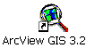 or by going to Start > Programs > ArcView GIS 3.2 > ArcView GIS 3.2.

- At the Welcome window click OK to Create a New Project with a New View and when prompted Would you like to add data to the View now? click Yes.

- Navigate to F:\\Accoleds on KLO\YourName\GIS_Data and select Kelowna_ct.shp, Kelowna_street.shp, Kelowna_water.shp (hold down the shift key to select multiple files) and click OK.

- These three themes will appear in the table of contents on the left side of the View (map window). To activate the themes check off the little box to the left of the theme name.

- The themes will open with default colours which we will now change. You can either double click on the theme or click on the Edit Legend button to do this.
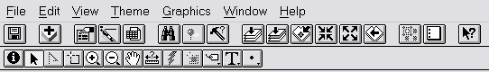

- Double click on the symbol to edit it.
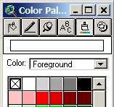
- Click the paintbrush button to get the colour palette.

- Select a colour and click on Apply for each theme
e.g. change Kelowna_ct.shp to light green, Kelowna_water.shp to light blue and
Kelowna_street.shp to red.

Close the Colour Palette window.
Part 4 – Adding a database table with data on seniors extracted from E-STAT.

- Click on the Kelowna_ct.shp theme to make sure that it is active (it should appear raised).
- Click the Open Theme Table button on the toolbar to open the attribute table for this theme.

- On the menu bar at the top, click on Window and select Untitled to display the Project window.
- Click on Tables to ensure it is active (highlighted) and click on Add.
- Navigate to F:\\Accoleds on KLO\YourName, select the file named senior.dbf and click on OK.
- Resize the 2 table windows so that they fit side by side with Attributes of Kelowna_ct.shp on the left and senior.dbf on the right.
- In the senior.dbf table click on the column heading Geocode – it will turn darker gray.
- In the Attributes of Kelowna_ct.shp table scroll over until you see the column heading Ctuid and click on it – it will turn darker grey.

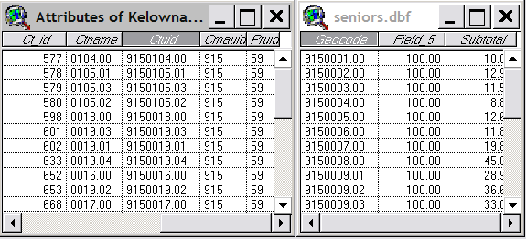

- On the ArcView toolbar click on the Join button.

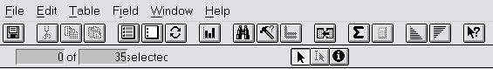

The senior.dbf table will disappear – it has actually been appended to the Attributes of Kelowna_ct.shp table.

Part 5 – Extracting a particular attribute (% of seniors) and displaying the values on the map.

- Return to View1 by going to the menu bar and clicking on Window and selecting View1.
- Double click on the Kelowna_ct.shp theme to bring up the Legend Editor.
- Change the Legend Type from Single Symbol to Graduated Colour.
- Change the Classification Field from <None> to Subtotal – this selects the % of seniors as the field for mapping.

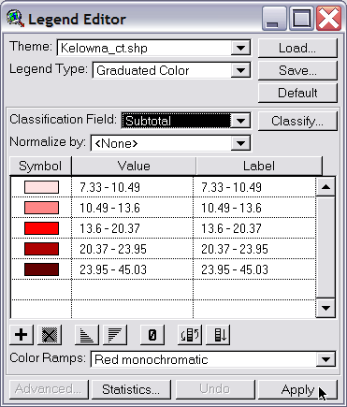

- Click on Apply at the bottom. You can experiment with different Colour Ramps and different methods of classification with the Classify… button.

Notice how the method of classification affects the map display.

- Close the Legend Editor. If you completed the optional section in Part 1, you should now see a very similar map to the one created in E-STAT, but with the water and roads.

Part 6 – Adding a DMTI point shapefile (golf courses) to the map.

- Click on the Add Theme button in the toolbar.

- Navigate to F:\\Accoleds on KLO\YourName\GIS_Data and select the file BCglf.shp and click on OK.
- Activate the theme by checking the box next to BCglf.shp. You should now see a number of green flags which represent golf courses. This shapefile actually contains all the golf courses in BC.

Part 7 – Selecting features that satisfy particular criteria: selecting the golf courses that are located within the Kelowna CA.

- Click on the BCglf.shp theme to make it active.
- Click on Theme on the menu bar at the top and in the drop down menu choose Select by Theme…
- When the Select by Theme window opens, change the value in the lower box from BCglf.shp to Kelowna_ct.shp and then change the value in the top box from Intersect to Are Completely Within.

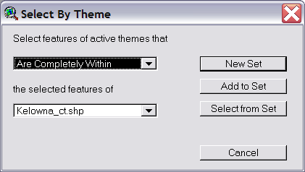

- Click on New Set. The flags inside the Kelowna CA will have turned yellow.
- Make sure the BCglf.shp theme is still active (raised) and click on the Open Theme Table button on the toolbar.

- On the toolbar, click on the Promote button. This will put all the selected golf courses – the ones located in the Kelowna CA – at the top of the list in the table.

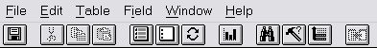

How many golf courses are located in the Kelowna CA? For the answer look above the title Attributes of BCglf.shp on the blue bar.

Close the Attributes of BCglf.shp window, being careful not to close the ArcView program.

Part 8 – Executing a query on Kelowna_ct.shp to determine how many of the census tracts contain more than 20% seniors by population.

- Click on the Kelowna_ct.shp theme to make it active.
- Click on the Query Builder button on the toolbar. A new window will open.

- In the new window, under Fields, double click on Subtotal.
- Then double click on the button with the > symbol.
- In the box type 20 after the > symbol. Your query statement should look like this graphic.

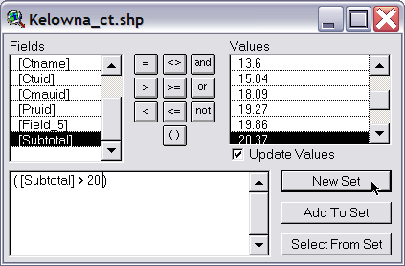

- Click on New Set. In the map window, you will see that the census tracts with more than 20% seniors by population have turned yellow indicating they have been selected.
- Click on the Open Theme Table button on the toolbar.
- On the toolbar, click on the Promote button. This will put all the selected census tracts – with more than 20 % seniors by population at the top of the list.

How many census tracts contain more than 20% seniors by population?

Part 9 – Performing spatial analysis by determining how many golf courses are within 1 km of census tracts that contain more than 20% seniors by population. Before doing this spatial query, it is necessary to set the unit of measurement for distance and also to set a map projection.

- Go to the menu bar, click on View and in the drop down menu select Properties.

- In the field that specifies Distance Units select kilometres.

In order to project the view, click on the Projection button, leave Standard selected and under Category select UTM-1983 and for Type choose Zone 11, then click OK.

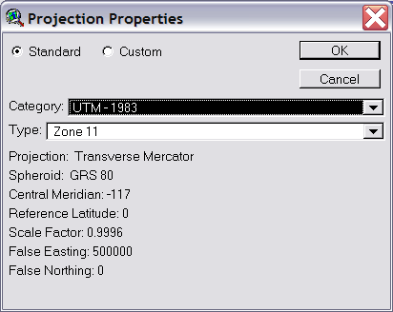

- Go back to your map window and click on the BCglf.shp theme to make it active.

- Go to the menu bar, click on Theme and choose Select by Theme….

- In the Select by Theme window, change the value in the lower box from BCglf.shp to Kelowna_ct.shp and then change the value in the top box from Intersect to Are Within Distance Of.
- The window will change and a new box Selection Distance will appear. Enter the number 1 in this box.

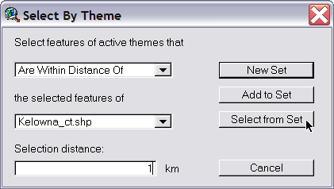

- Click on Select from Set.

How many golf courses are within 1 km of a census tract containing more than 20% seniors by population? Hint: Use the same strategy as before in answering the questions.

Clear the selected census tracts by clicking on the Kelowna_ct.shp theme to make it active, then click on the Clear Selected Features button on the toolbar.

Part 10 - Creating a shapefile of the selected golf courses.

- Click on the BCglf.shp theme to make it active.
- On the menu bar, click on Theme and select Convert to Shapefile.
- In the window that pops up navigate to F:\\Accoleds on KLO\.YourName\GIS_Data and name the file Kelowna_golf.shp.
- Respond No when asked “Do you want the new shapefile to be saved in projected units?
- Respond Yes when asked “Add the shapefile as theme to the view?”
- Remove the check mark beside BCglf.shp and check the box beside Kelowna_golf.shp.

Your map will now show a number of dots representing the golf courses within 1 km of the census tracts with more than 20% seniors by population.

Part 11 – Changing the symbol for the selected golf courses.

- To change the dots to golf flags, double click on the Kelowna_golf.shp theme to bring up the Legend Editor.
- Double click on the symbol.
- Scroll down on the Marker Palette until you see the golf flag and select that symbol.
- Change Size: to 16. You can also change the colour by clicking on the Paint brush and selecting a colour from the palette.

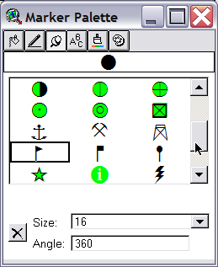

- Close the palette windows and click Apply.
- Close the Legend Editor.

Part 12 - Labelling the golf courses.

- From the toolbar, click on the Zoom In tool, then drag a box around the inner part of the Kelowna CA to zoom in closer to that area – try to include all the golf courses and the census tracts with the high percentages of seniors.

- Click on the Kelowna_golf.shp theme to make it active.
- Go to the menu bar and click on Theme and select Auto-label.
- The Label Field should be Name, Find Best Label Placement should be bulleted, and Scale Labels should be checked.
- Click OK.

Part 13 – Creating a layout. This will be the finished map.

Let’s change the theme names, first, to make the legend more readable.
- Click Kelowna_water.shp to make it active.
- On the menu bar, click on Theme and select Properties.
- In the box Theme Name change the name from Kelowna_water.shp to Water.

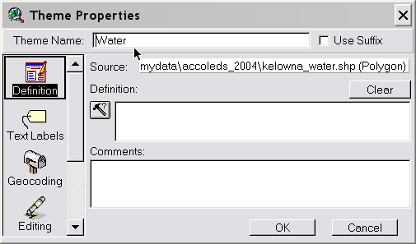

- Click OK.
- Repeat the process for the other themes: changing Kelowna_streets.shp to Streets, Kelowna_glf.shp to Golf Courses, and Kelowna_ct.shp to % Seniors.

Let’s create the layout.
- On the menu bar, click on View and select Layout. This will bring up the Template Manager
- In the Template Manger window, select the style you prefer (portrait or landscape) and click OK.

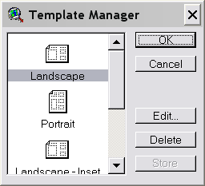

- Your map and legend are placed in the Layout along with a scale bar, a north arrow and a title. Each of these is a separate object that can be moved or resized or even deleted.
- Double click on the title and rename it to something more descriptive of the map, e.g. % Seniors and Golf Courses in Kelowna. You can also resize and move the title. If you want to use the scale bar, double click on it and change the units to kilometres. You can also change the intervals and number of left divisions. Click OK to view the changes for the scale bar. Move and resize the north arrow, also, if you like.

You now have a finished product. You can either print or export this map.

To export:
- On the menu bar, click on File and select Export.
- In the Export window, navigate to your personal folder, select JPEG or Windows bitmap as the file type or (try both formats to compare the quality). Name the file Seniors_golf.

You have produced a graphic file version of your map that could be placed on a web page (jpeg format) or inserted into a word processing or powerpoint document (jpeg, bitmap, windows metafile).

Part 14 - Save your project

- Click File on the menu bar and select Save Project As.
- Navigate to your personal folder and give the file a name. Projects in Arcview have an .apr extension and contain information about the specifications and settings for all the elements: views, tables, layouts and charts.

GIS Data sources used

DLI Cartographic Boundary Files:
- gct_915b02a_e.e00 (census tracts)
- gsrn915r02a_e.e00 (skeletal streets)
- ghy_915h02a_e.e00 (water)

DMTI Streets, British Columbia, Points of Interest (POI)
- BCglf shape file including:
* BCglf.avl | * BCglf.sbn
* BCglf.dbf | * BCglf.sbx
* BCglf.lyr | * BCglf.shp
* BCglf.prj | * BCglf.shx

